Project Documentation: ConnectReactDjango

Creating the Django project and React.js Application and integrating the both frontend and backend.

Table of Contents :

1. Introduction

2. Setting Up the Django (Backend)

3. Creating the React (Frontend)

4. Using Axios for API Requests

5. Handling CORS Policy

1. Introduction :

This documentation provides step-by-step instructions for setting up a Django backend and a React frontend for the "ConnectReactDjango" project. The project aims to demonstrate the integration of Django and React, enabling data retrieval from the Django backend using Axios while addressing CORS policy issues.

2. Setting Up the Django ( Backend ) : Please follow the commands

2.1. Initial Setup :

Create a folder named "connectreactdjango" and navigate into it:

# mkdir connectreactdjango

# cd connectreactdjango

Install Python and pip:

# sudo apt update

# sudo apt install python3-pip

Create a virtual environment:

# sudo apt install python3-virtualenv

# virtualenv connectrdj

Activate the virtual environment:

# source connectrdj/bin/activate

Install Django:

# pip install django

2.2. Project Setup :

Install Django REST framework:

# pip install djangorestframework

Create a Django project:

# django-admin startproject djangobackend

# cd djangobackend/

Create a Django app named "api":

# python manage.py startapp api

2.3. Django Configuration :

Open the settings.py file in the django backend folder and make the following changes:
Add 'rest_framework' and 'api' to the INSTALLED_APPS list.
Update ALLOWED_HOSTS to include your server's private and public IP addresses.
Open port 8000 in your security group.

2.4. Database Setup :

Migrate the database to create the necessary tables:

# python manage.py makemigrations
# python manage.py migrate

Create a superuser for the Django admin panel:

# python manage.py createsuperuser

2.5. Running the Django Server :

Start the Django server:

# python manage.py runserver 0.0.0.0:8000

Access the Django admin panel in your browser by navigating to “ http://your_server_ip:8000/admin “ and log in with the superuser credentials.
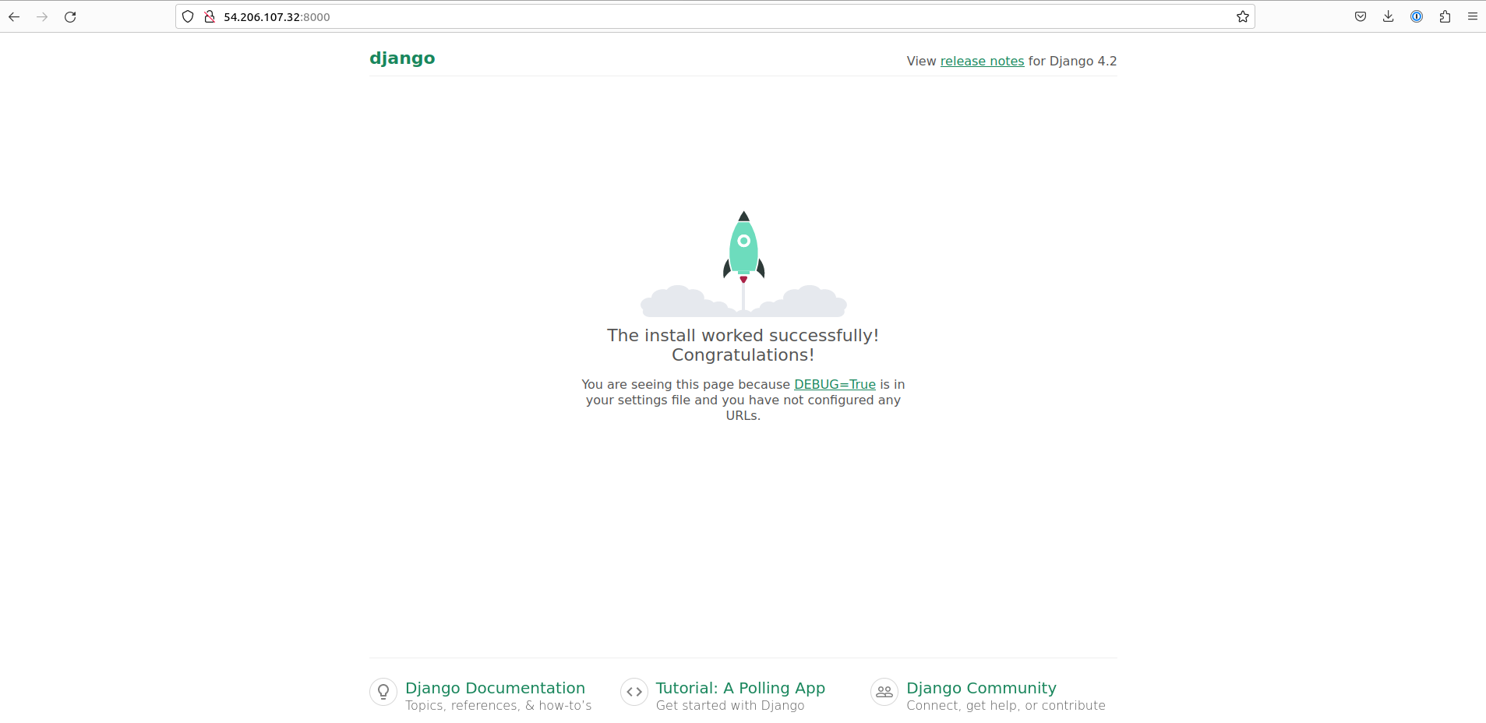

2.6. API (APPLICATION) Configuration : Here the Application Name is “API”

Create a ‘serializers.py’ file in the ‘api app directory’ and define a serializer for the Student model.

Create a ‘views.py’ file in the api app directory to define a view that lists all students.

Create a ‘urls.py’ file in the api app directory to define the API endpoints for the Student model.

Include the API URLs (Application) in the main urls.py file of the djangobackend project.

2.7. Testing the API (Application) :

Start the Django app server:
# python manage.py makemigrations
# python manage.py migrate

# python manage.py runserver 0.0.0.0:8000

Access the Student data by navigating to “http://your_server_ip:8000/admin” in your browser.
Login using the username and password.

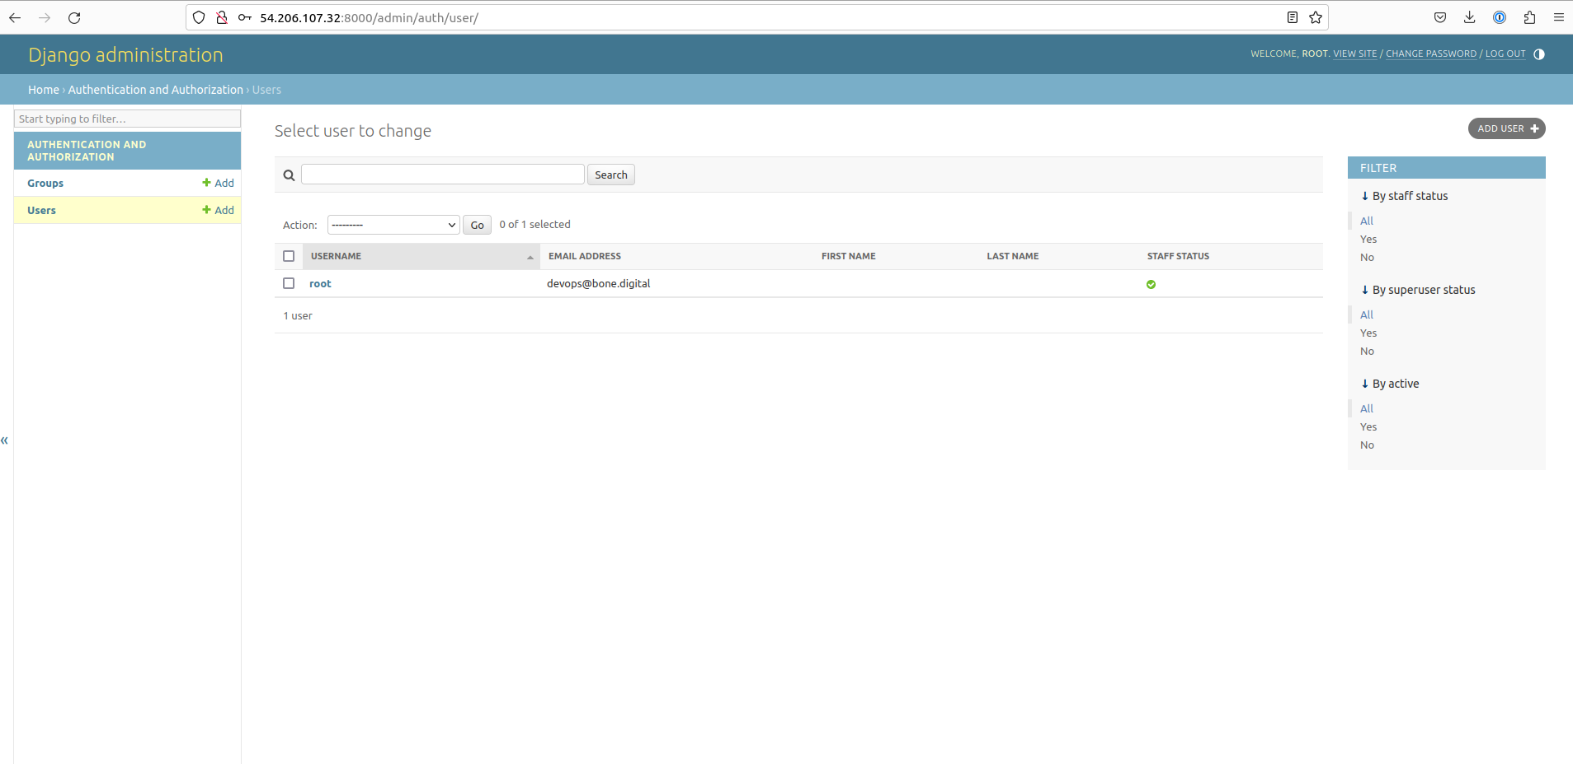

2.8. Optional: Disabling Browsable API :

To disable the browsable API, add the following lines to the settings.py file:

======================================================================

REST_FRAMEWORK = {
'DEFAULT_RENDERER_CLASSES': ('rest_framework.renderers.JSONRenderer',)
}

=======================================================================

3. Creating the React Frontend :

3.1. React App Setup :

Open a new terminal tab and navigate to the connectreactdjango directory.

Install Node.js 14 and create a React app named "reactfrontend":

curl -o- https://raw.githubusercontent.com/nvm-sh/nvm/v0.38.0/install.sh | bash
source ~/.bashrc
If shell comes out of the environment, go indside again using: source connectrdj/bin/activate
nvm install 14
nvm use 14
npx create-react-app reactfrontend
cd reactfrontend

Start the React app:

# npm start
Open port 3000 in security group.
Access the React app in your browser by navigating to “ http://your_server_ip:3000 ”
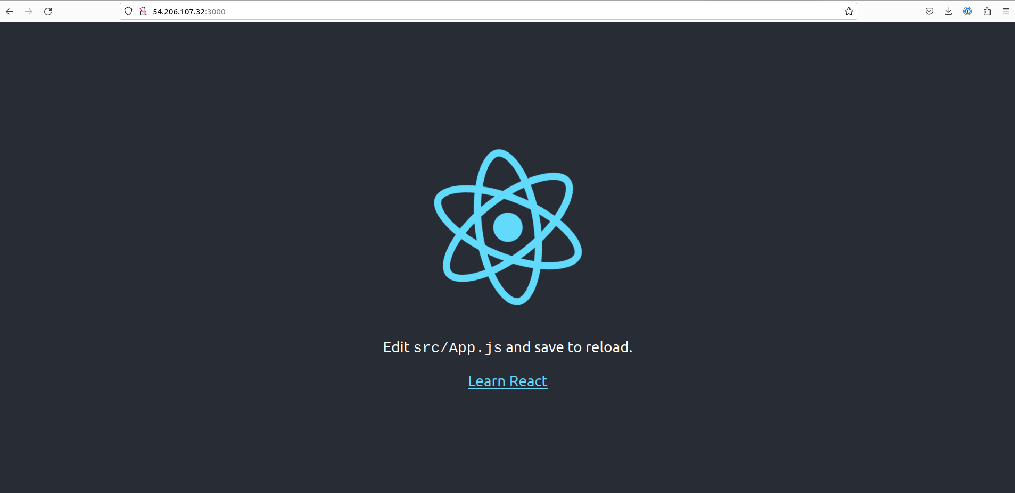

3.2. Customizing the React App :

Edit the App.js file in the src directory of your React app to customize its content according to your requirements. (Creating an Header Connect React.js to Django)

4. Using Axios for API Requests :

4.1. Installing Axios

Install Axios in your React app:

# npm install axios

4.2. Fetching Data :

Import and use the useState and useEffect hooks to fetch data from the Django API.

Update your React app to display the fetched student data.

5. Handling CORS Policy :

Installing Django CORS Headers

Install django-cors-headers in your Django project:

# pip install django-cors-headers

CORS Configuration :

Open the settings.py file in the djangobackend folder and configure CORS settings:
Add 'corsheaders' to the INSTALLED_APPS list.
Add "corsheaders.middleware.CorsMiddleware" to the MIDDLEWARE list.
Define CORS_ALLOWED_ORIGINS with the URL of your React frontend.

CORS_ALLOWED_ORIGINS = [ 'http://your ip address:3000',]

Testing CORS :

Start the Django server again:

# python manage.py runserver 0.0.0.0:8000
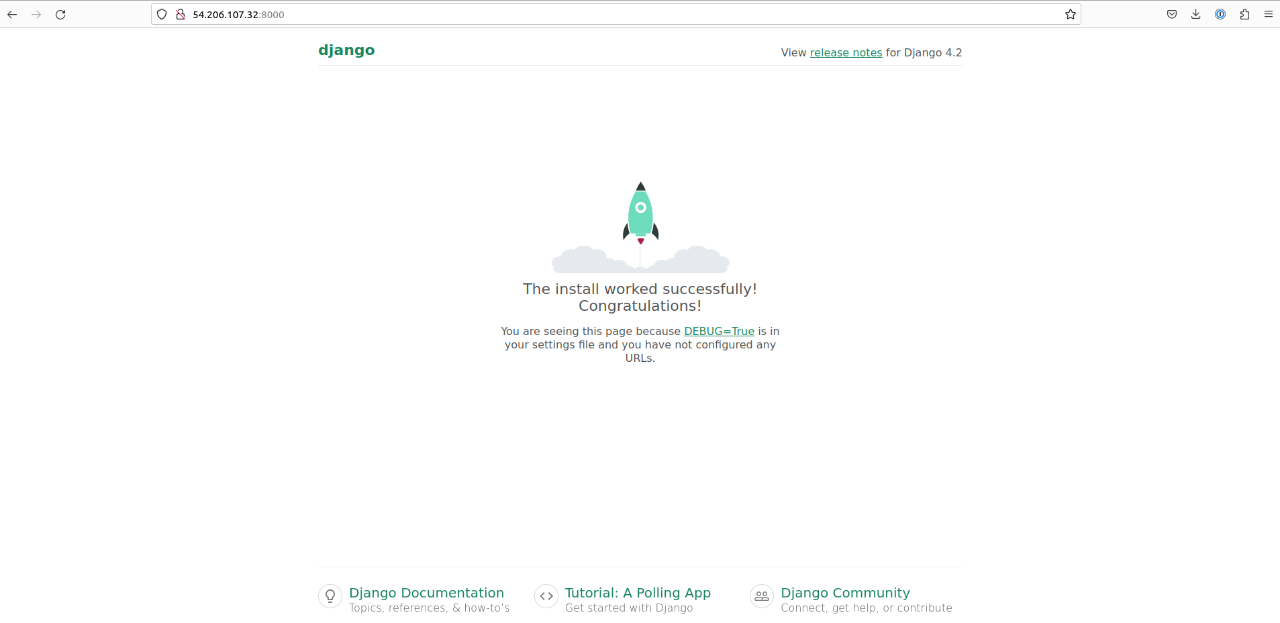

Start the React app:
# npm start

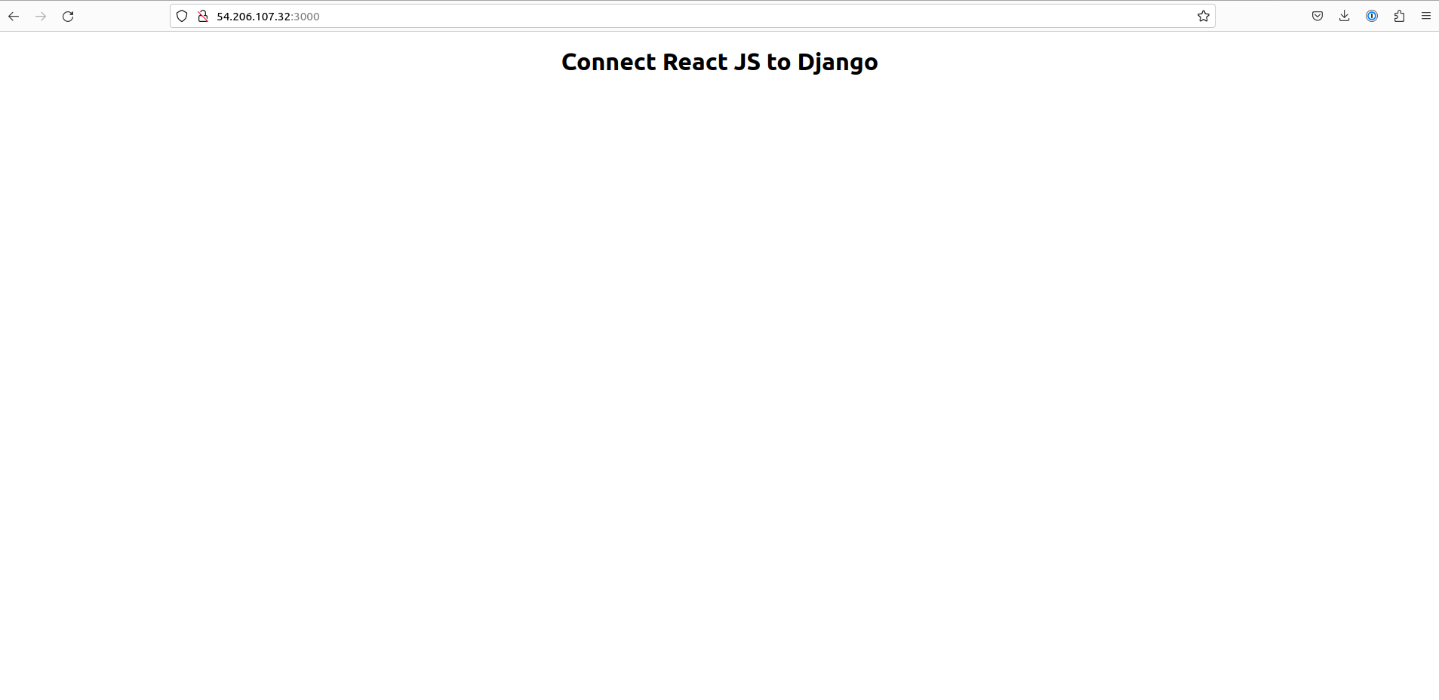
Access your React app and it should now be able to fetch data from the Django API without CORS errors.

Customize your React app's interface to display the student data retrieved from the API.
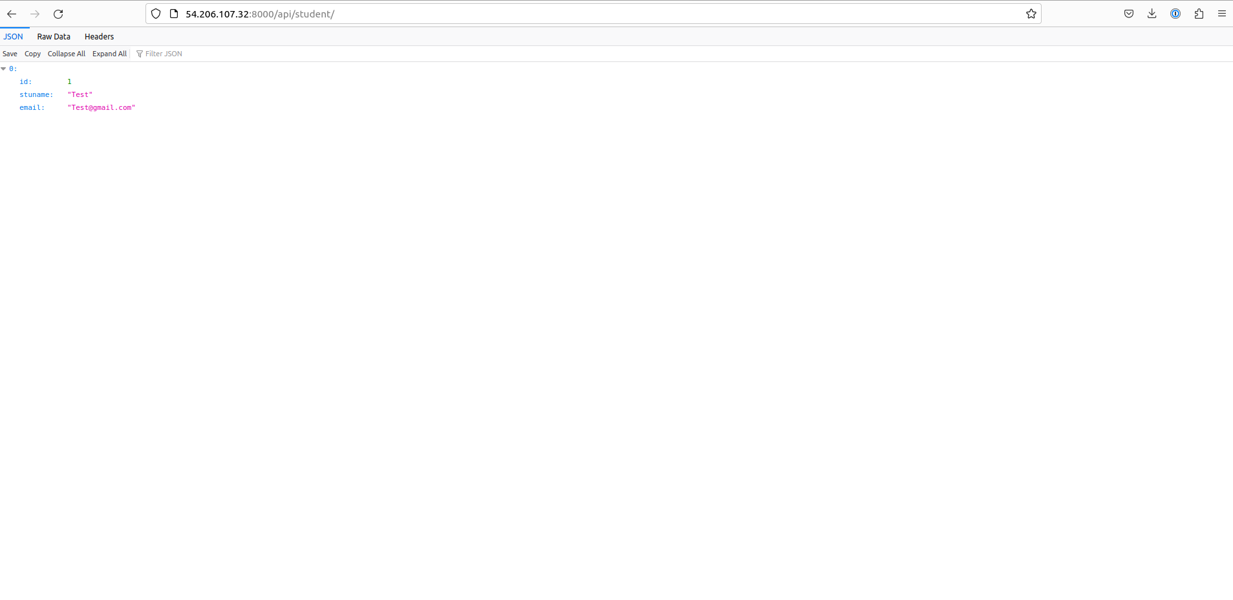

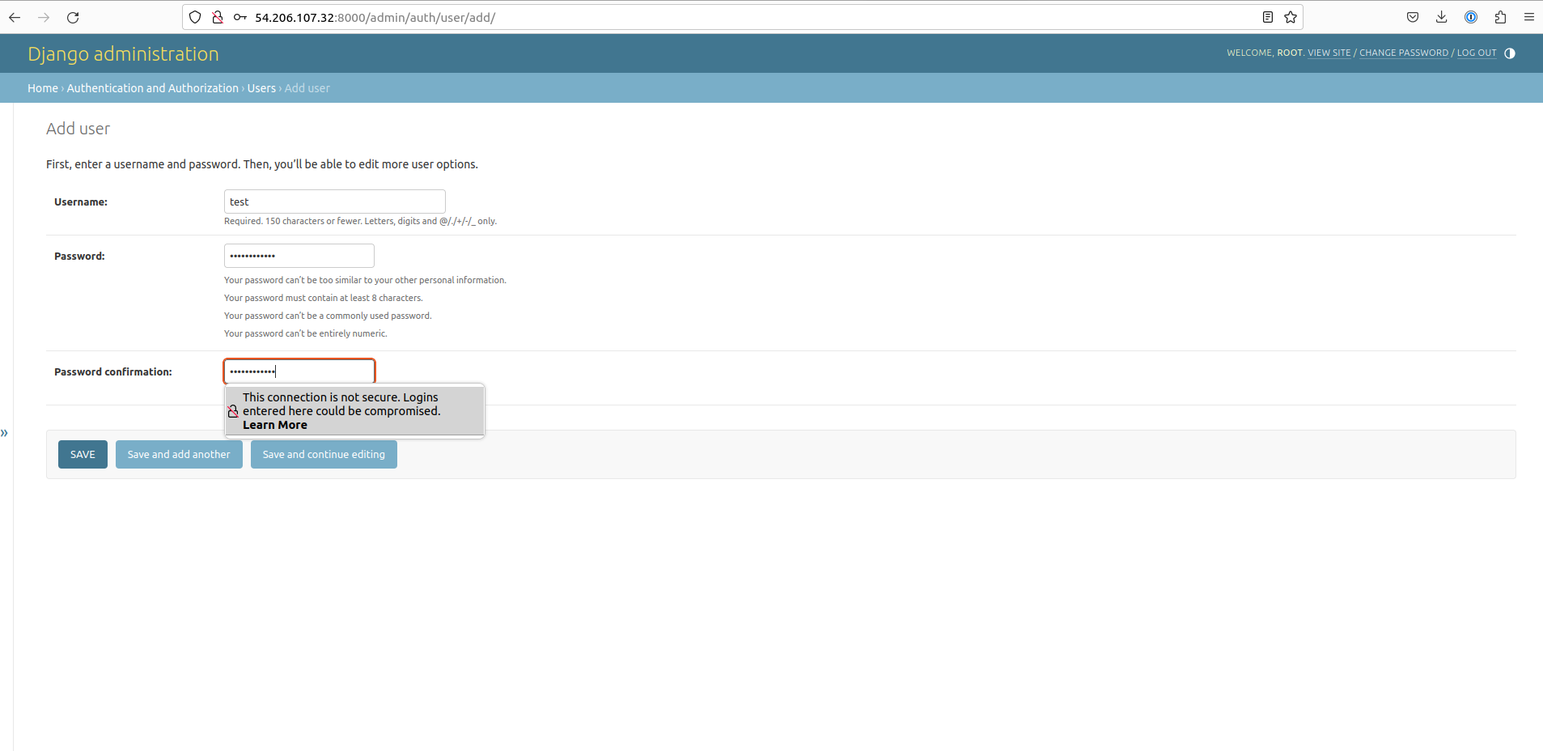
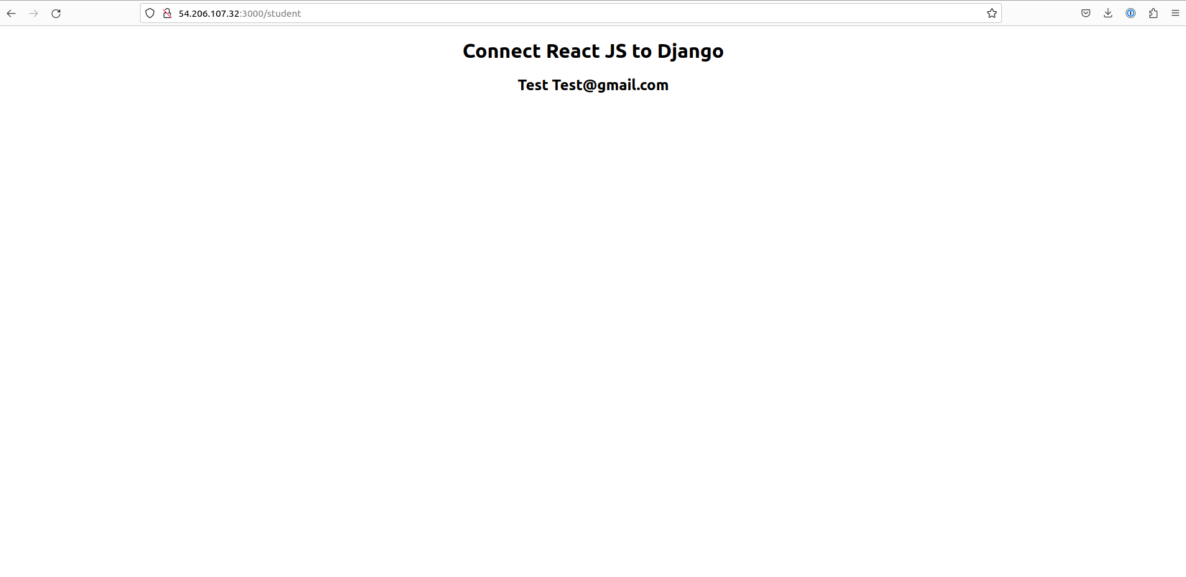

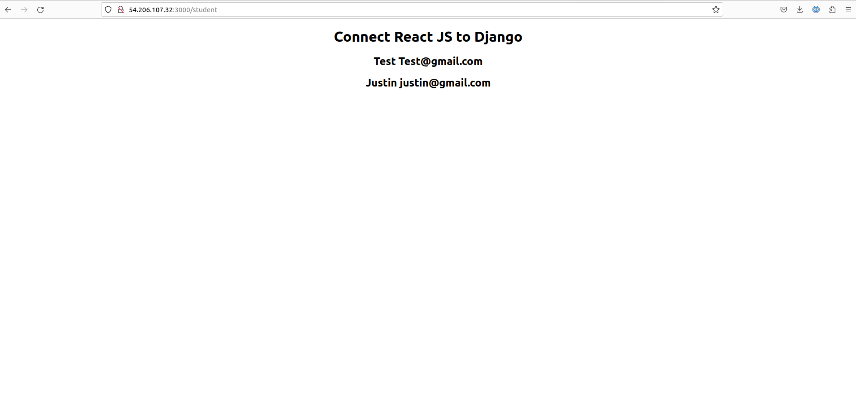
The time required to understand the provided documentation and complete the steps will vary depending on your familiarity with the technologies involved and your prior experience. Here's a rough estimate of the time required for each section:
------------------------------------------------------------------------------------------------------------
Time Estimation For Sample project :
Setting Up the Django Backend (Estimated time: 2-3 hours)
Initial Setup: 15-30 minutes
Project Setup: 15-30 minutes
Django Configuration: 30-45 minutes
Database Setup: 15-30 minutes
Running the Django Server: 15-30 minutes
API Configuration: 1-2 hours (including creating serializers, views, and URLs)
Testing the API: 15-30 minutes
Optional: Disabling Browsable API: 15-30 minutes
Creating the React Frontend (Estimated time: 1-2 hours)
React App Setup: 30-45 minutes
Customizing the React App: 30 minutes - 1 hour
Using Axios for API Requests (Estimated time: 1-2 hours)
Installing Axios: 15-30 minutes
Fetching Data: 30 minutes - 1 hour
Handling CORS Policy (Estimated time: 30 minutes - 1 hour)
Installing Django CORS Headers: 15-30 minutes
CORS Configuration: 15-30 minutes
Testing CORS: 15-30 minutes
Total estimated time: Approximately 4-8 hours

